IOD
- Property Booking Process (Done by: Kevin Muho)

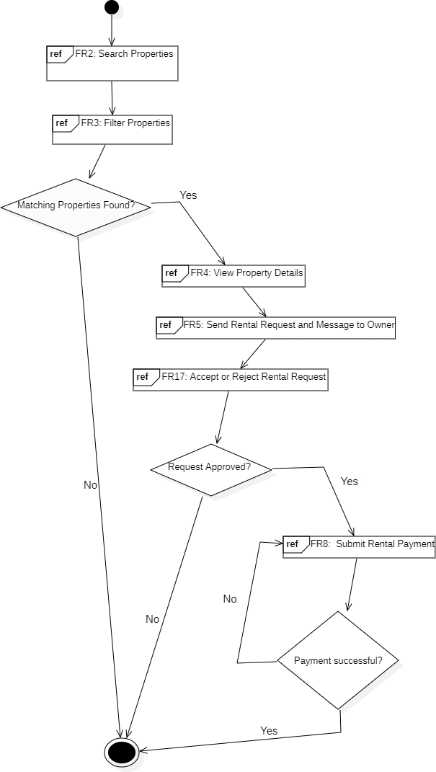

- Property Listing & Managment (Done by: Anisa Domi)
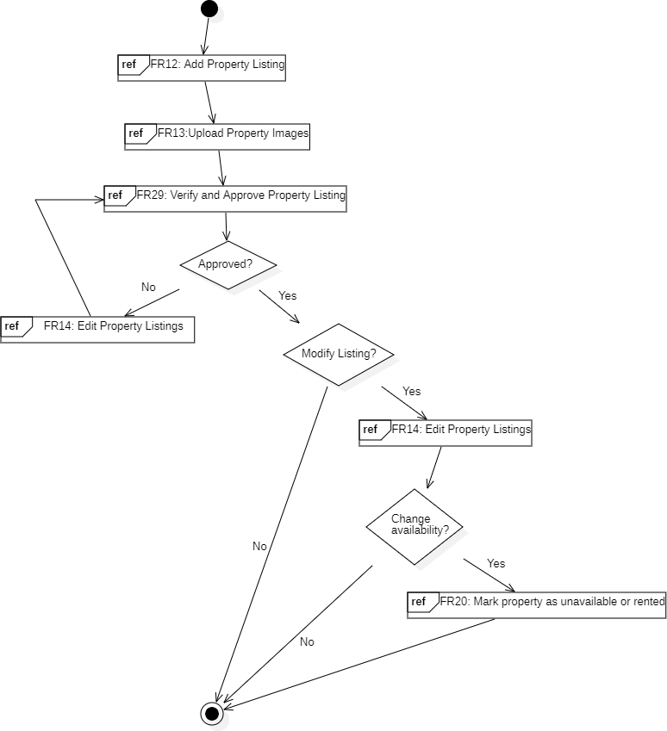

- Complaint & Issue Managment (Done by: Desard Lybeshari)
